Secret missions:

Upload secret mission.pdf file in objects of the bucket.

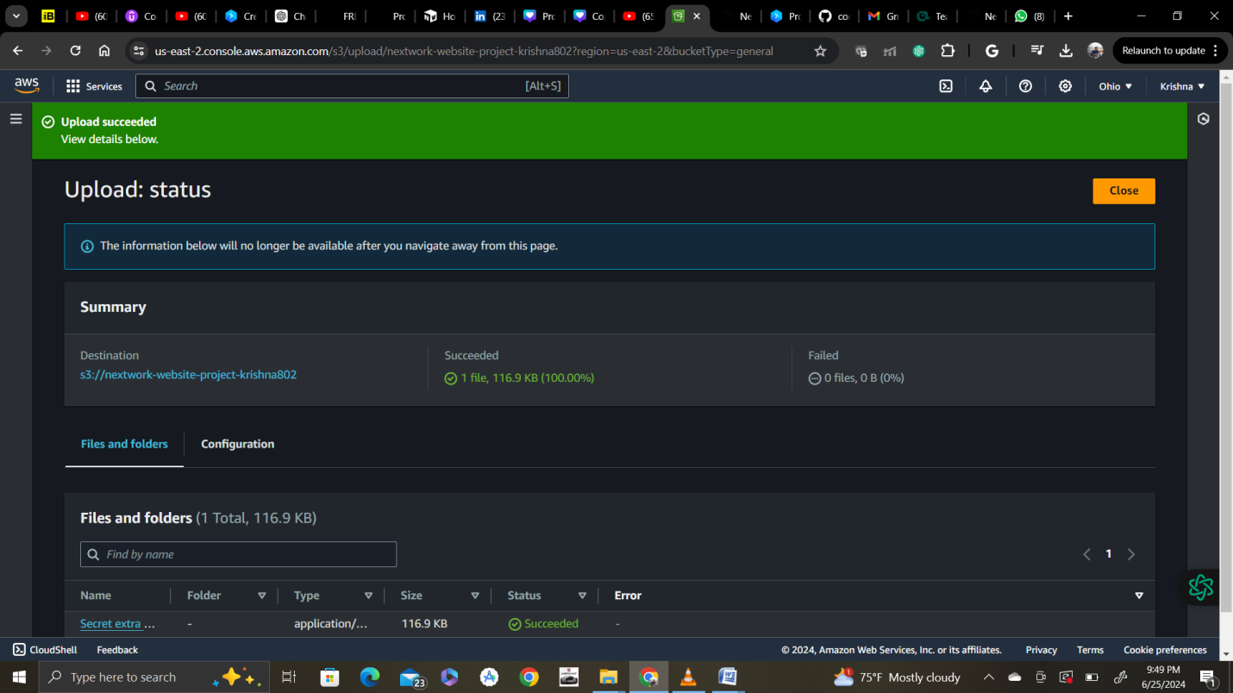

Click on uploaded file and select actions tab with presigned url

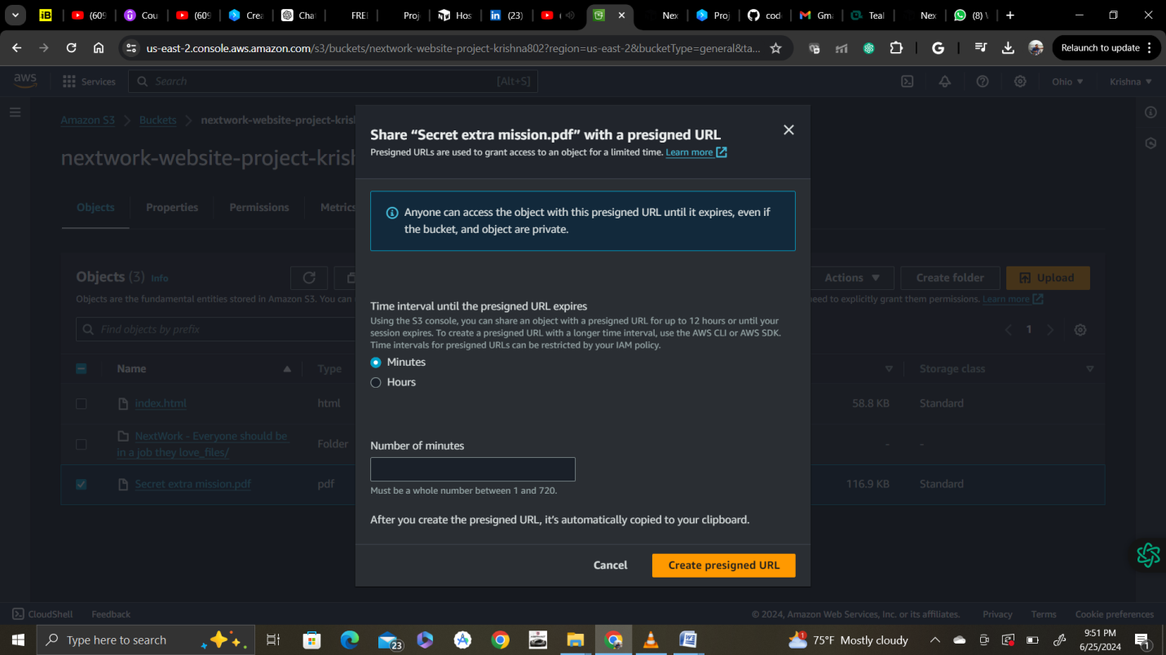

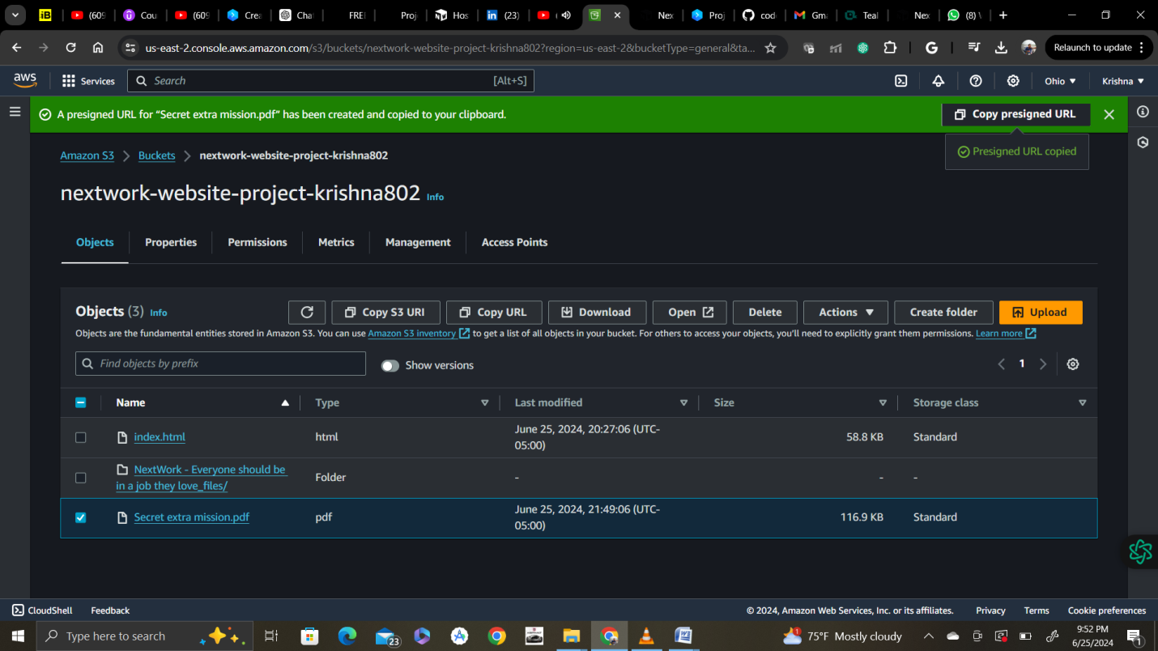

Like when you first uploaded the website files, the file is **private by default**. This time, instead of making the object public, you create a presigned URL to access the file.

* In the Objects tab, select the checkbox next to Secret extra mission.pdf.
* From the Actions menu, select Share with a presigned URL.

💡 **What is a presigned URL?**  
When you need to **temporarily and securely share** an object with a person or group of people, you can create a presigned URL.  
  
A presigned URL is generated by an AWS user who has access to the object (that's you!). When you create the URL, you must configure how long the URL will be valid. Then, you can share this URL with the users who will get access to the object.

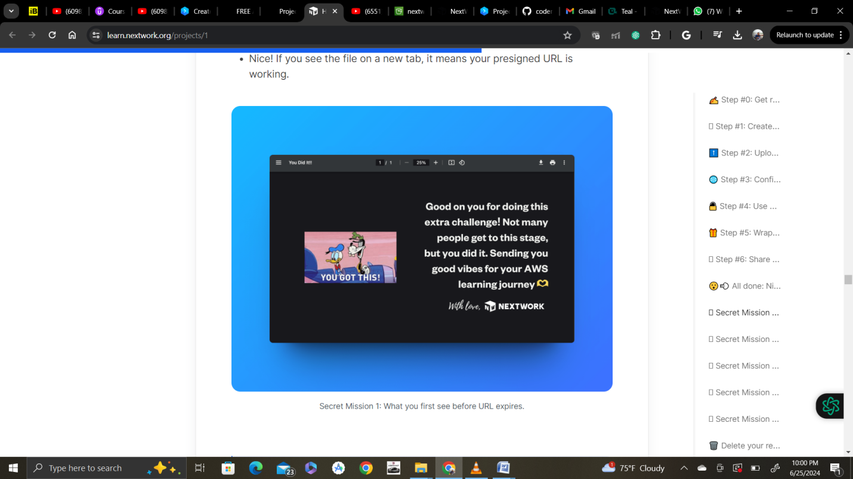

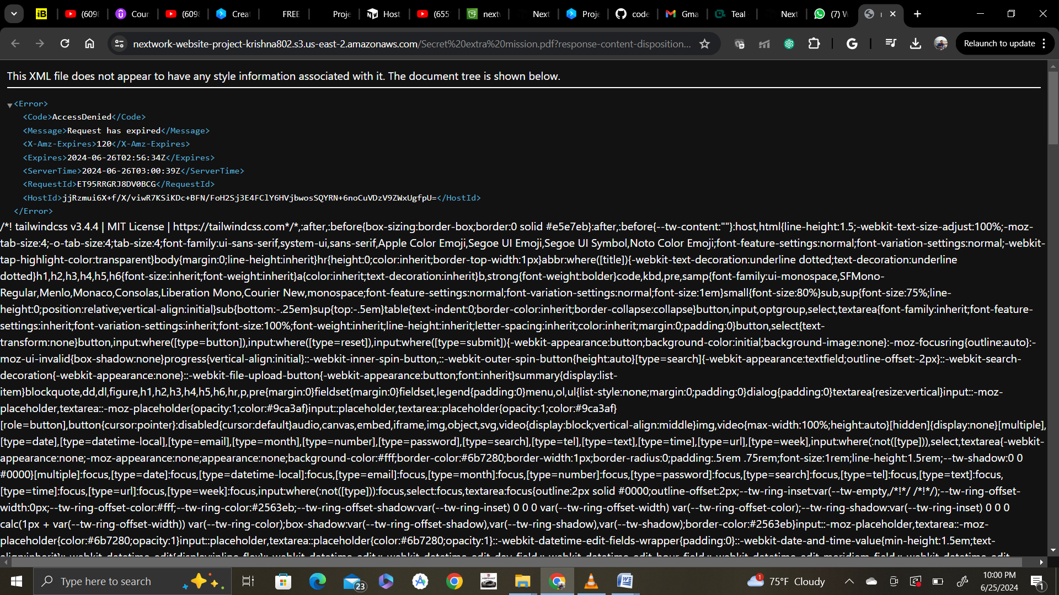

Secret mission 2 :

Using bucket policy to secure bucket

Go to permissions tab and edit bucket policy

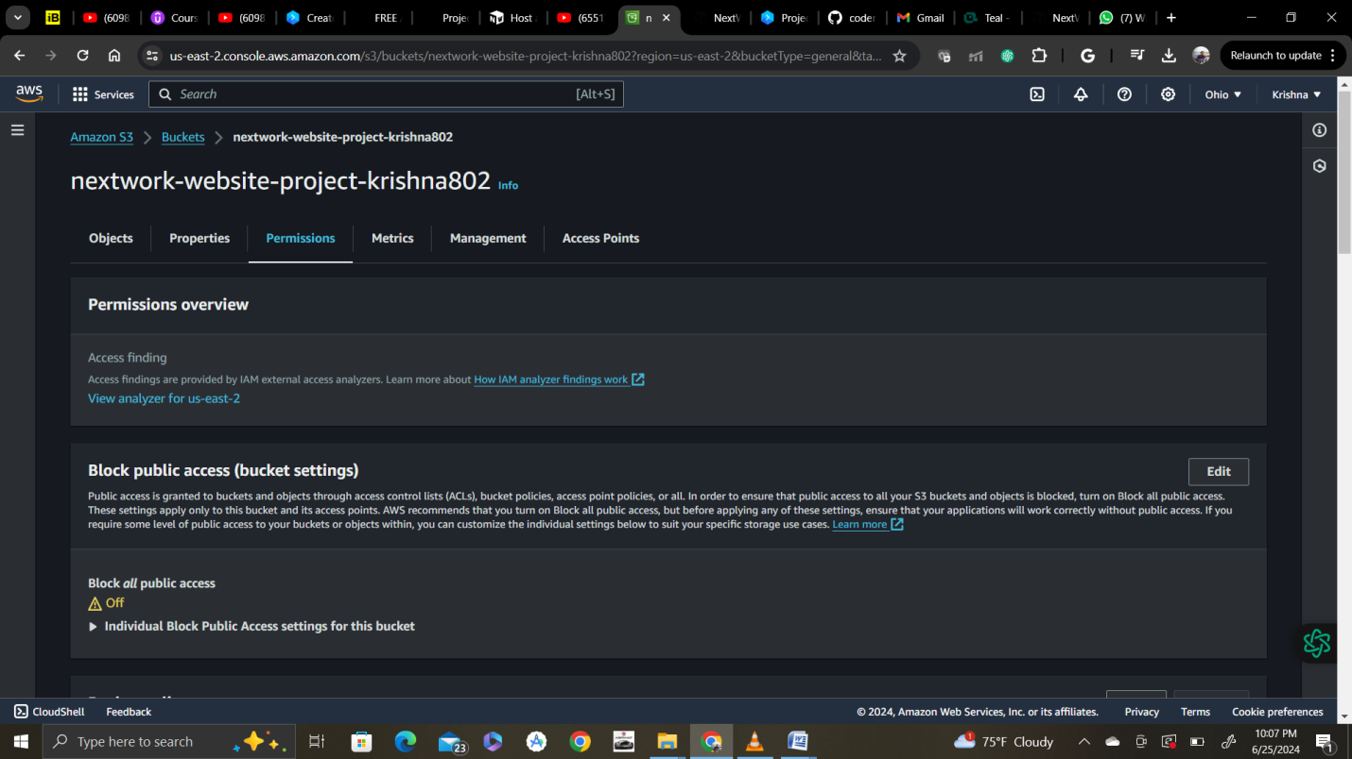

{

"Version": "2012-10-17",

"Id": "MyBucketPolicy",

"Statement": [{

"Sid": "BucketPutDelete",

"Effect": "Deny",

"Principal": "*",

"Action": "s3:DeleteObject",

"Resource": "arn:aws:s3:::<bucket-name>/<object-name>"}]

}

Change bucket name and object name as below:

{

"Version": "2012-10-17",

"Id": "MyBucketPolicy",

"Statement": [{

"Sid": "BucketPutDelete",

"Effect": "Deny",

"Principal": "*",

"Action": "s3:DeleteObject",

"Resource": "arn:aws:s3:::nextwork-website-project-krishna802/index.html"}]

}

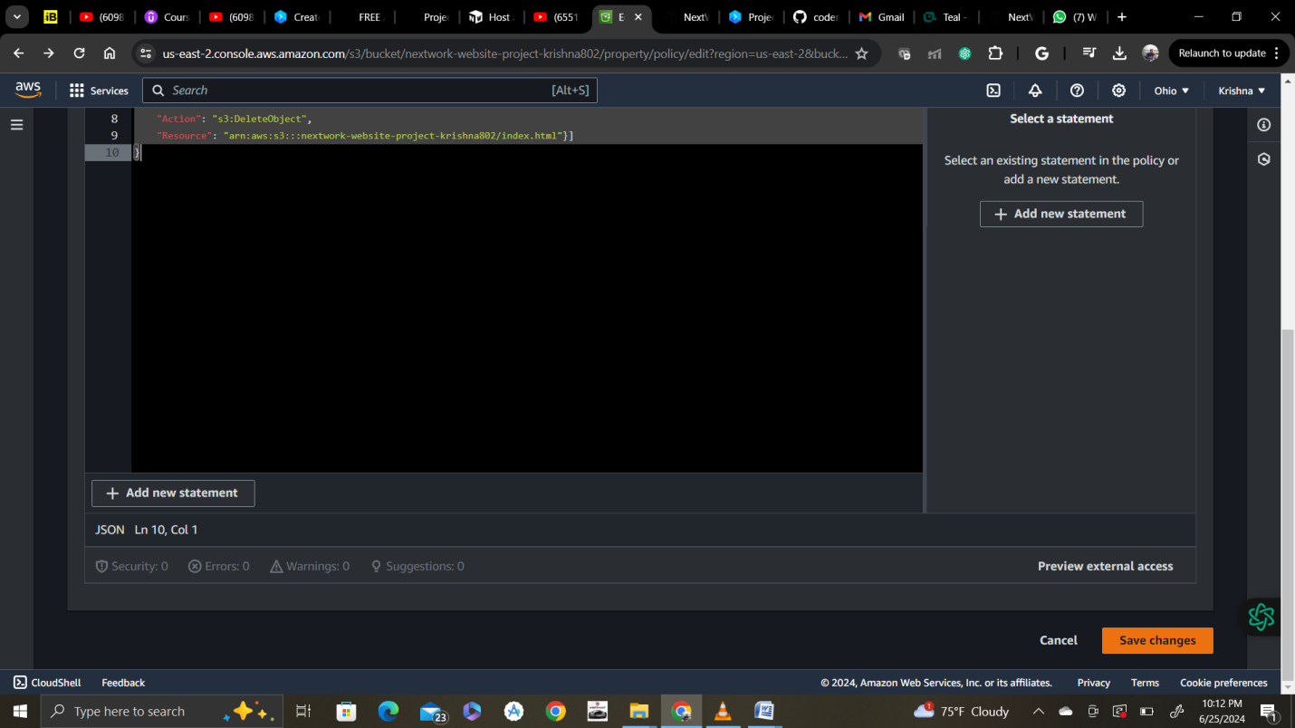

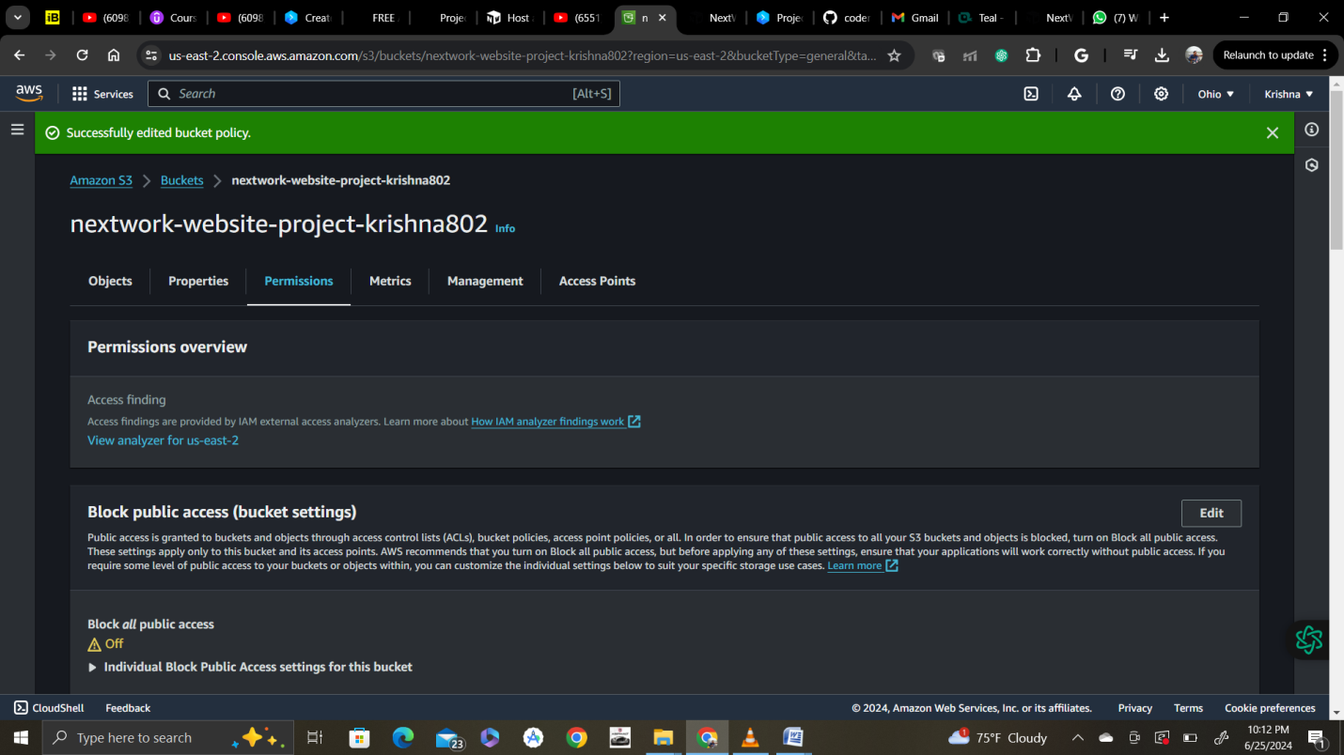

Now try to delete html file and it should not let you or access should be denied

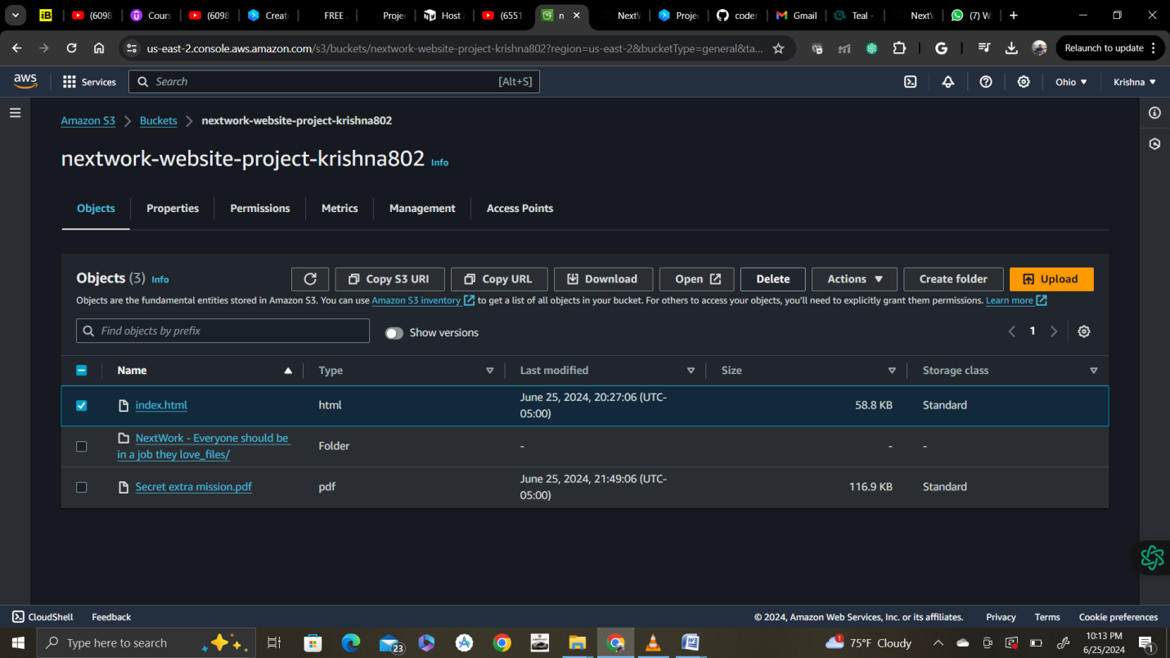

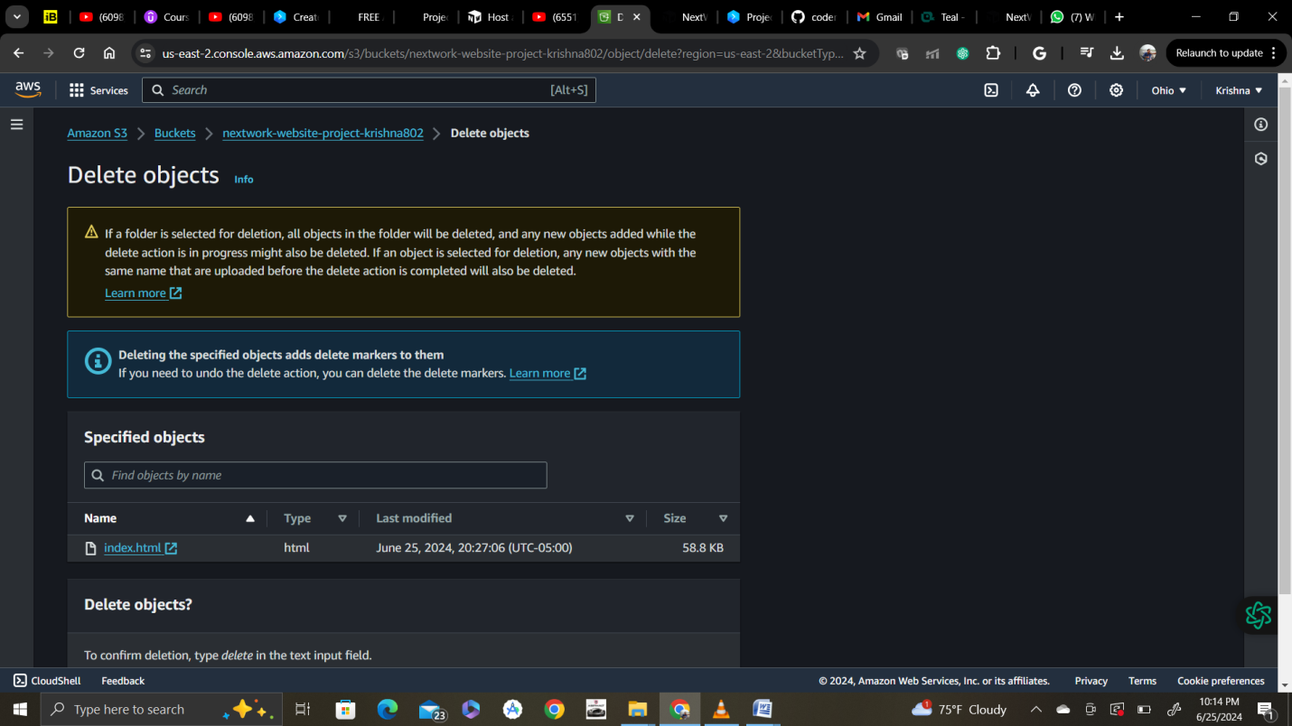

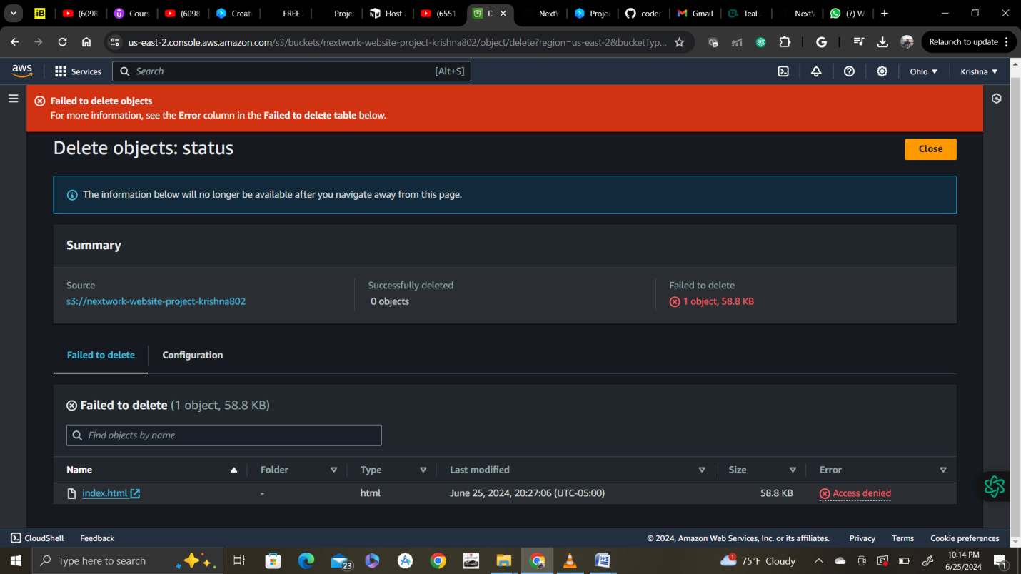

Secret mission 3:

Nice work, you've set up a policy to prevent deletion of website files. Did you know you can still **update** the website by editing the HTML file and uploading it to your S3 bucket again?

💡 Amazon S3 is an object storage service, so you must **upload new files instead of editing files** within S3. This action replaces the existing object in your bucket. You cannot edit the contents of an object; instead, you must replace the whole object.

* On your computer, load the index.html file into a text editor (for example, Notepad for Windows or TextEdit for Macbooks).
* Find the text Everyone <First Name> should be in a <span class="text-span">

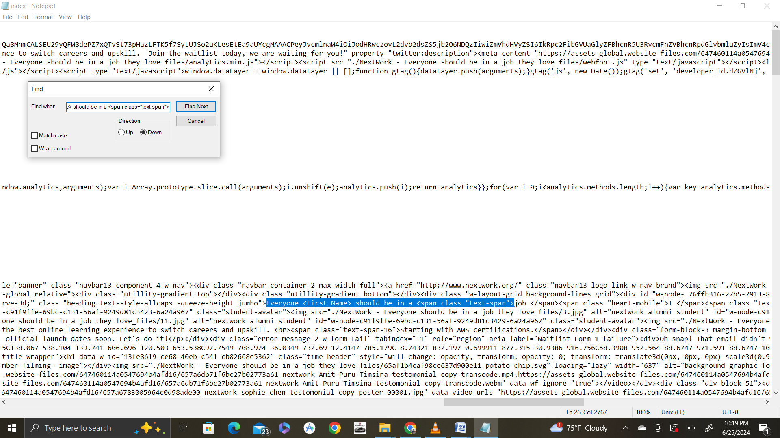

* Replace Everyone <First Name> with your name.

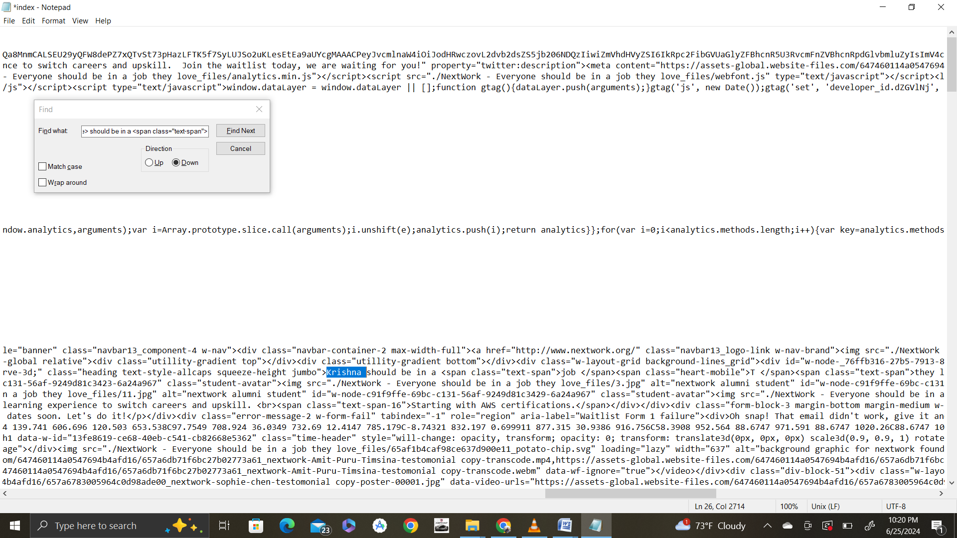

Now upload new file directly like above

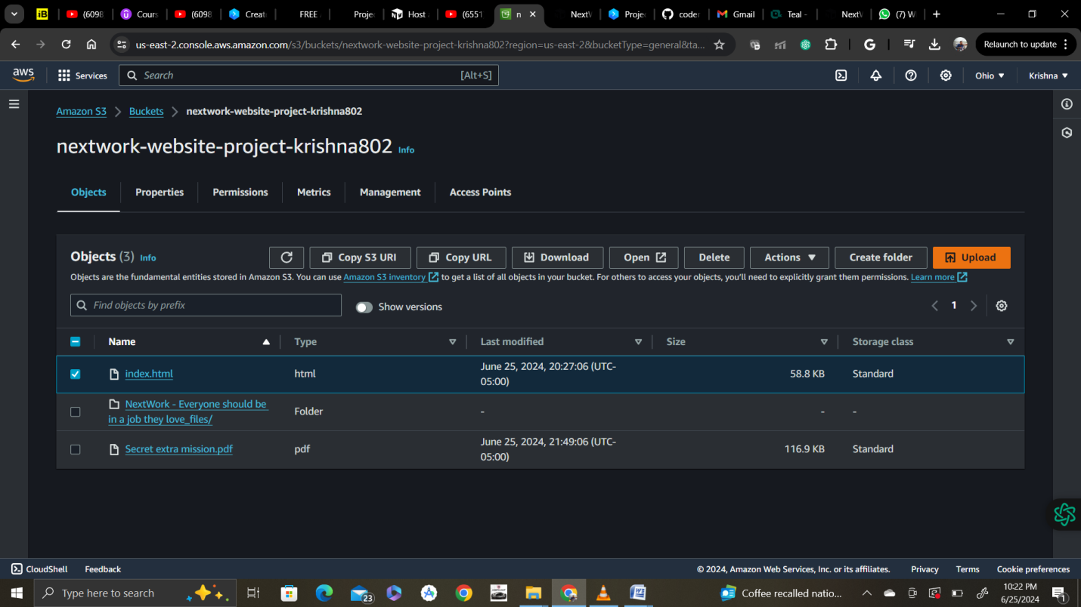

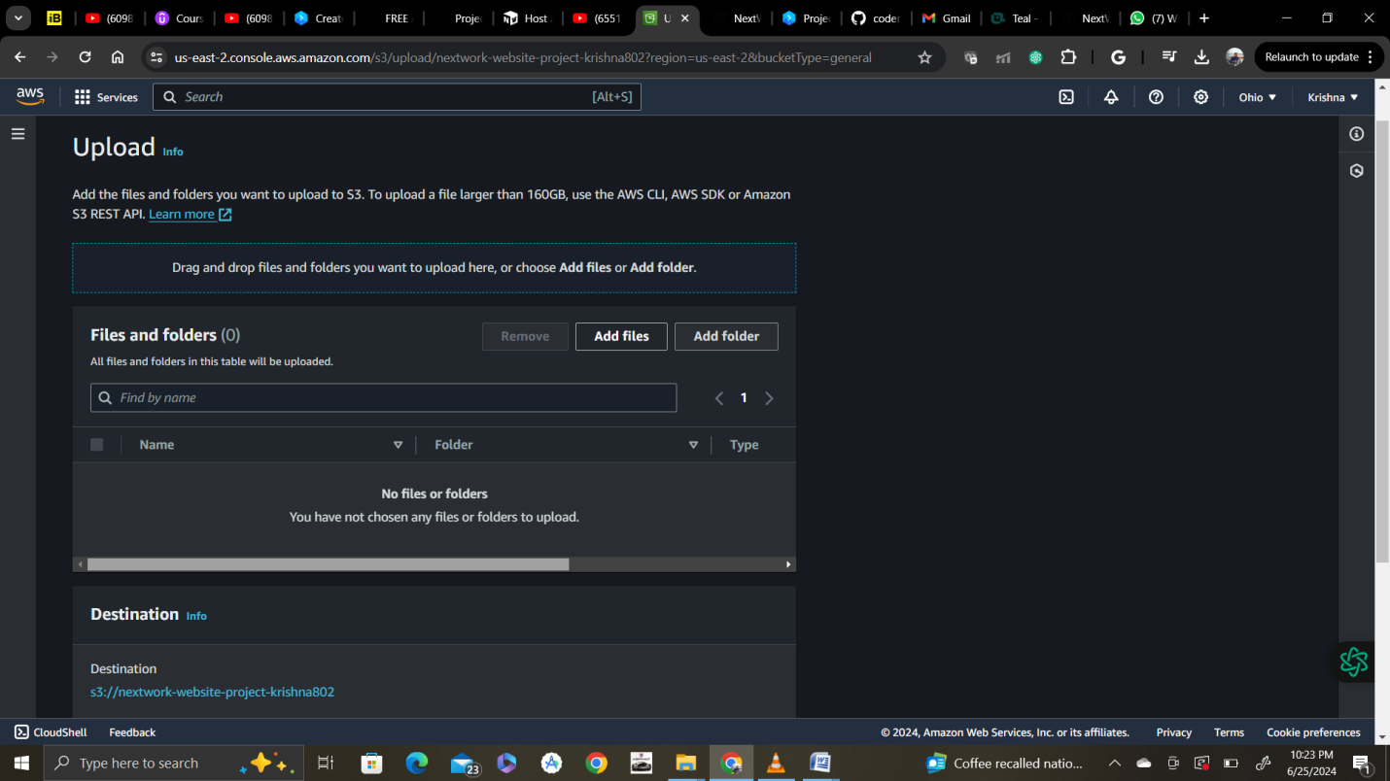

Click upload and new file will be uploaded.

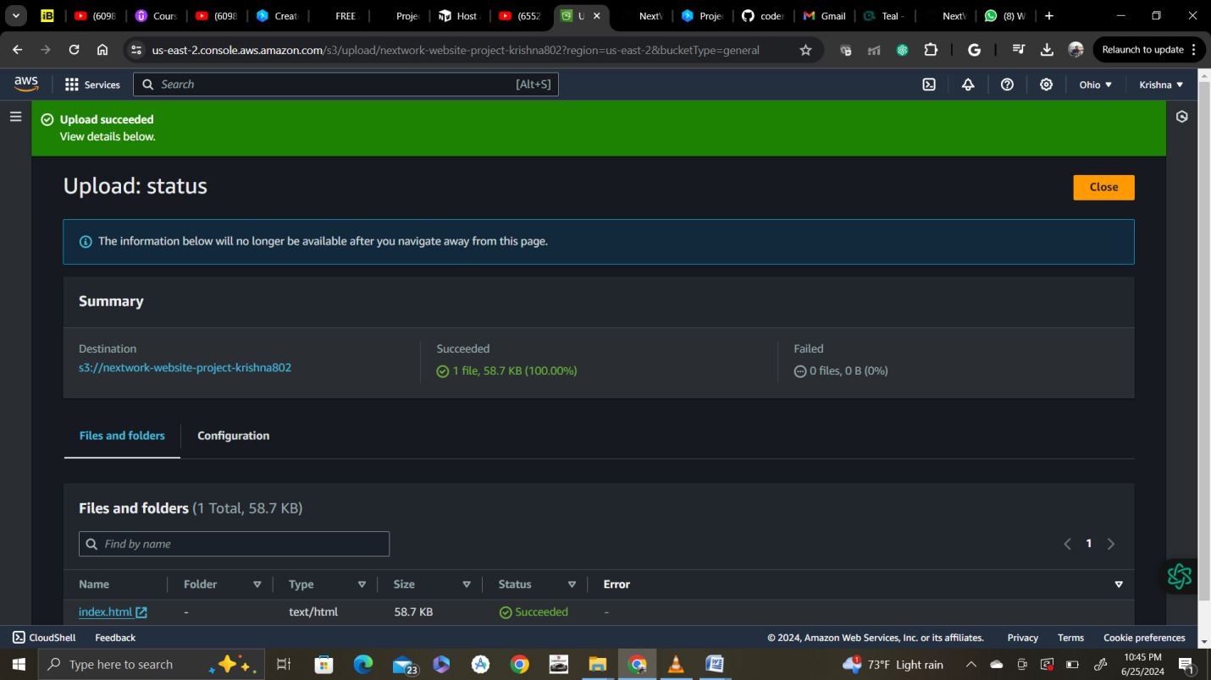

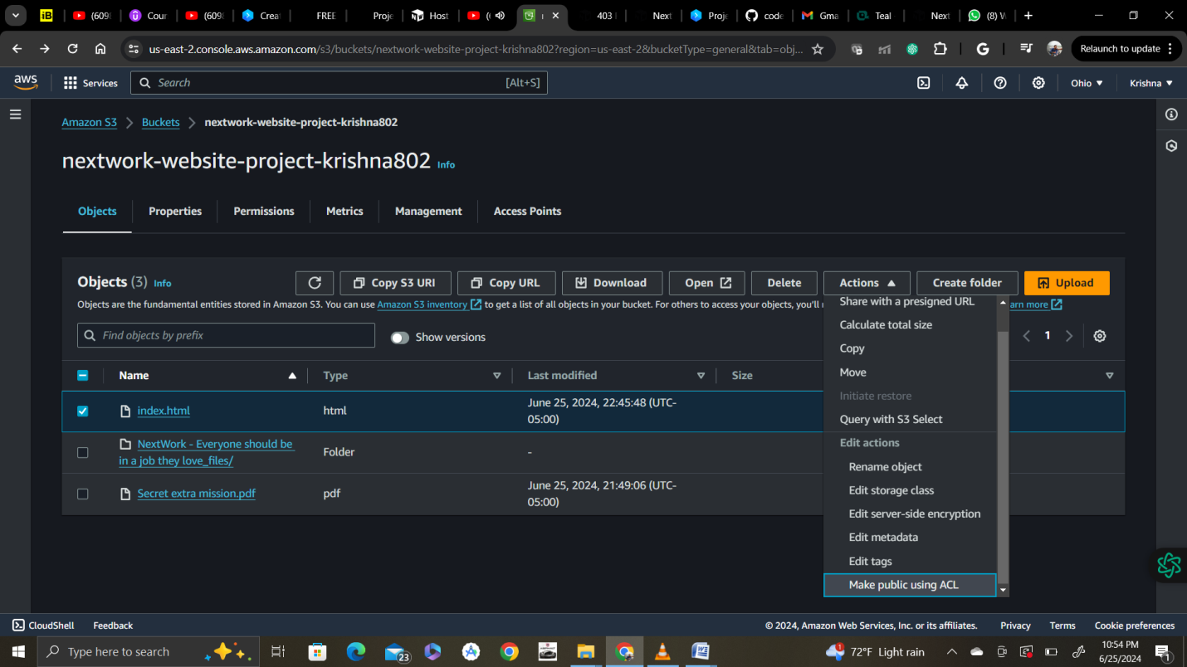

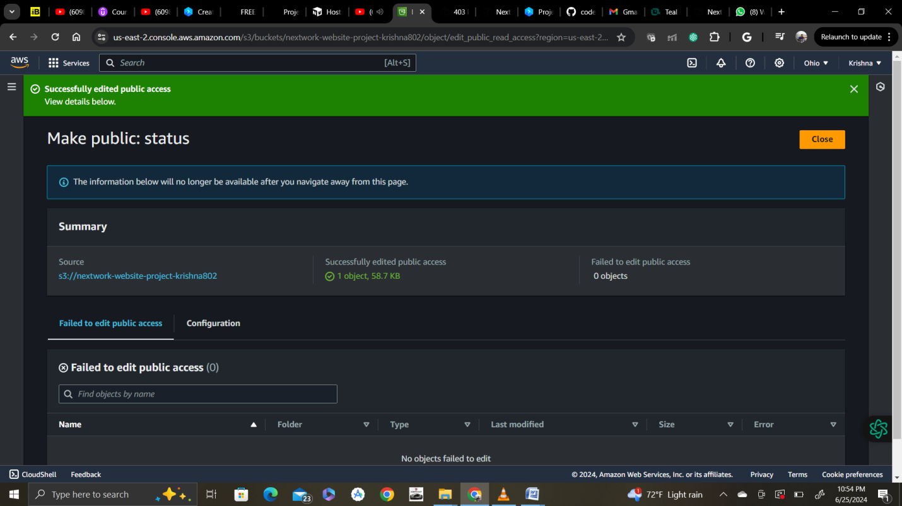

Now reload website and it should work.

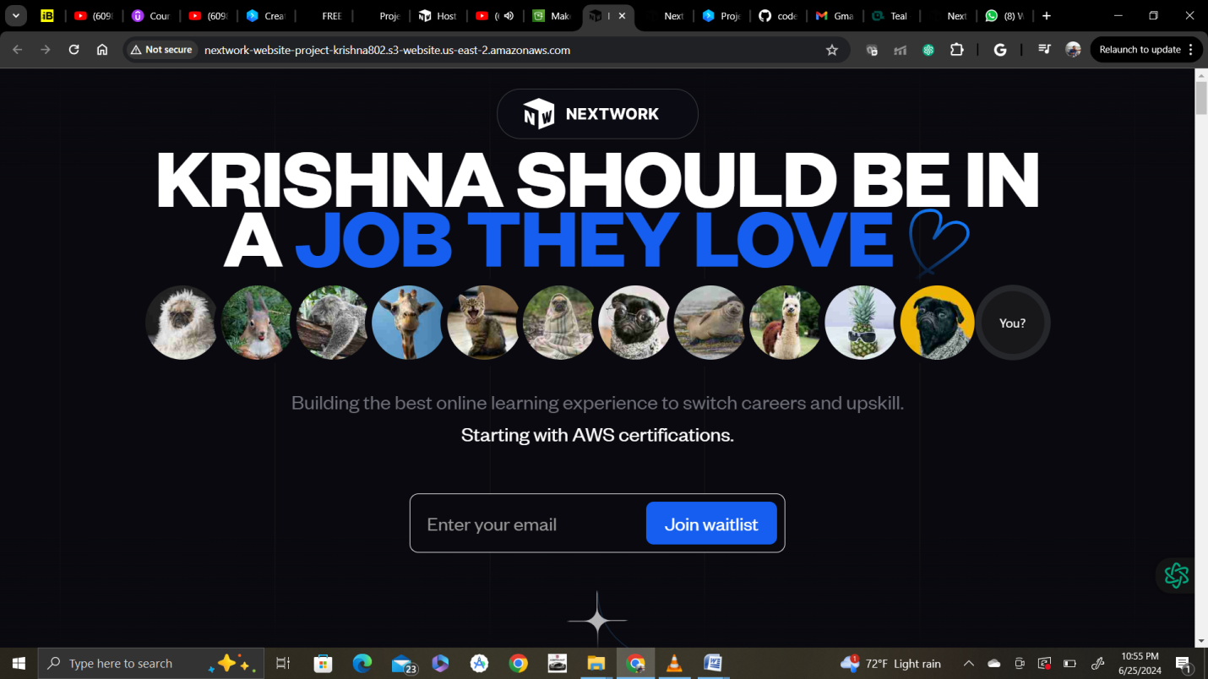

**Bucket versioning**

**NOTE:** you'll need complete the previous secret mission to see this one in action!

Secret missions 4:

Select show toggle show versions

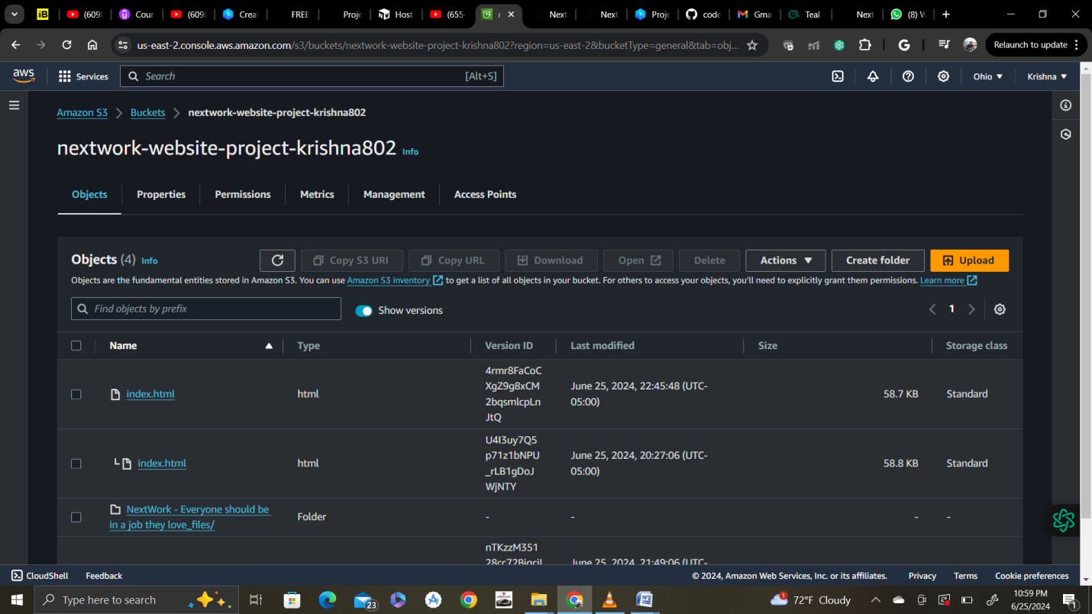

💡 **Oooo what does Show versions mean?**  
Back when you first set up your S3 bucket, we asked to you enable bucket versioning!  
  
When bucket versioning is turned off, changes to objects can't be undone. For example, if you upload a new version of a file, the old file is replaced with the new one. The original file is lost. If you delete a file, it is permanently deleted, and you can't get it back.  
  
Bucket versioning is turned off by default. However, when versioning is turned on, changed and deleted versions of files are saved. It's also important to remember that once you turn on bucket versioning, you cannot turn it off.

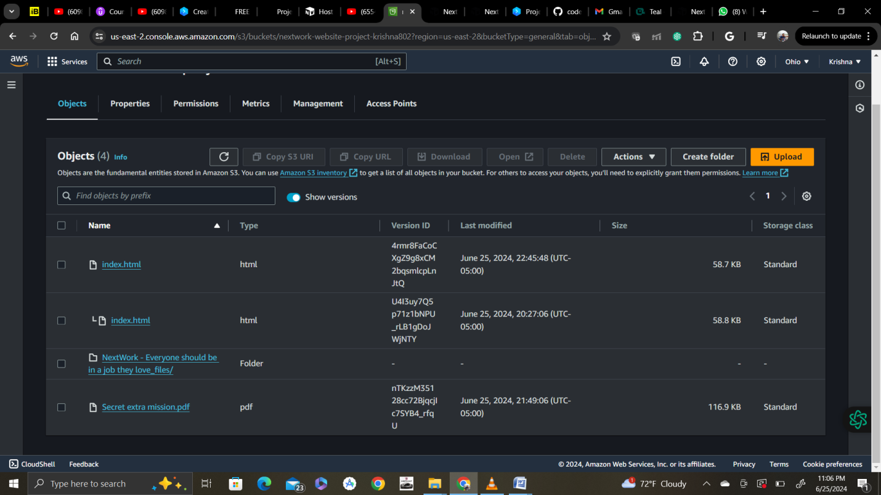

V1:

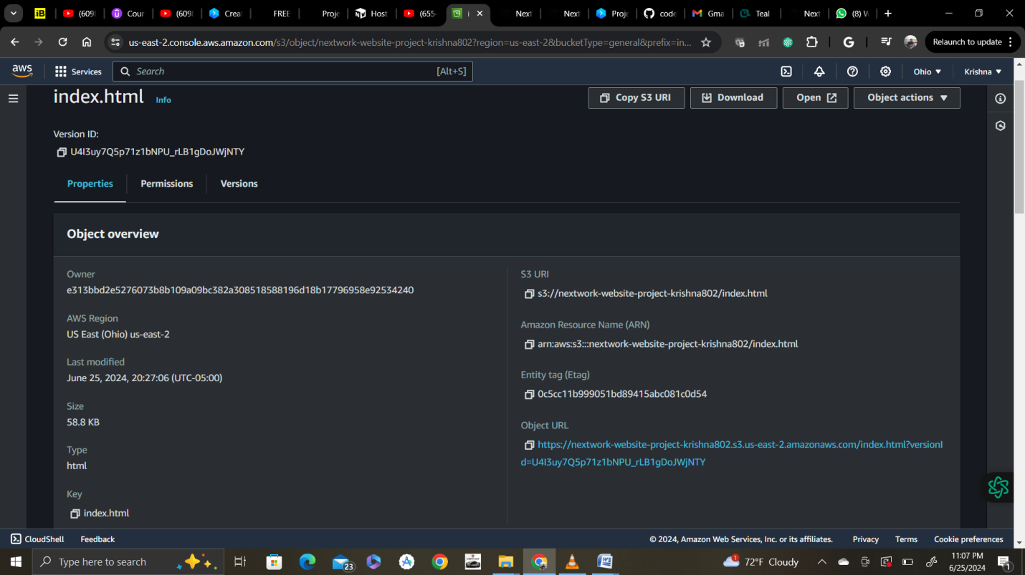

V2:

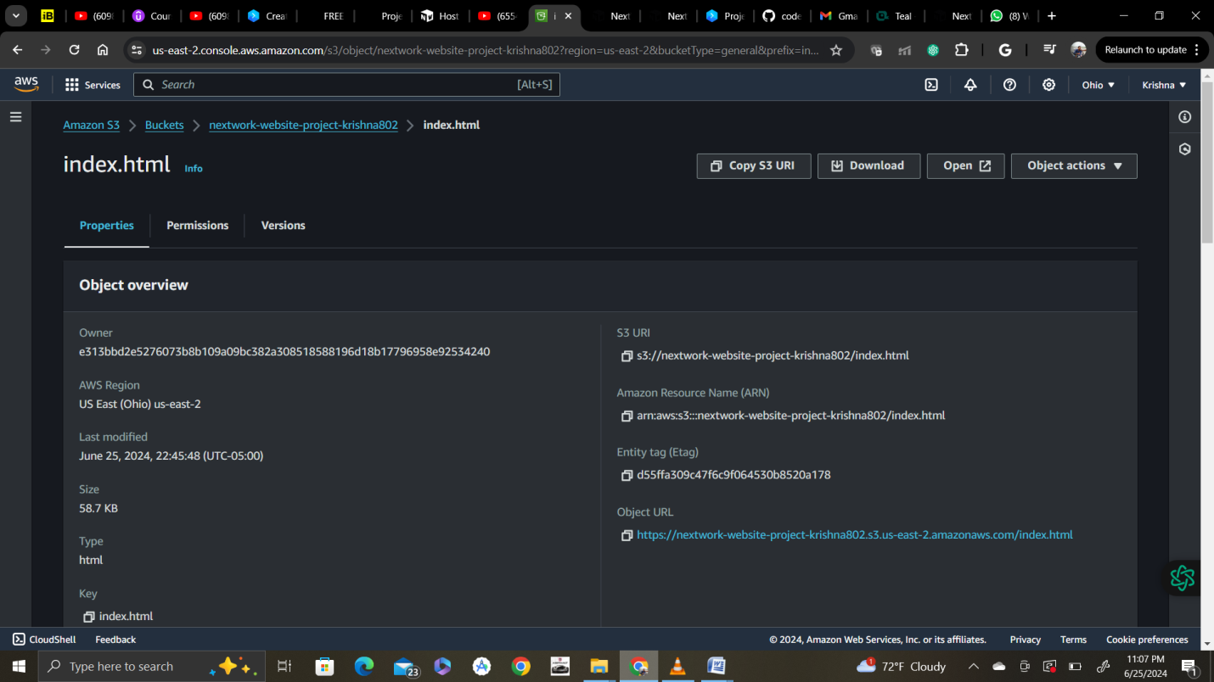

Secret mission 5:

### The ultimate secret mission: Host your website on your own special domain!

Ready to do something more advanced? We'll be stepping into a new service!

When you enabled website hosting on S3, notice how the URL for your website has already been determined for you?

In this final secret mission, you will use Amazon Route 53 to purchase* your own domain (there's a hack to make this as cheap as $3 USD) and host your website there, so you have a clean and customised URL!

 Wait a second... did you just say **PURCHASE?!!?**  
Yes, that means this task does come with a cost! But we wouldn't recommend it if we didn't think this is one of the best investments you could make while learning AWS. It can cost as little as $3 USD, and it's completely up to you whether this is something you'd like to invest in!

**Here are a few things this investment will give you...**

1. You will learn how to purchase a domain name AND connect your own website to the domain.
2. You will own a domain that's now uniquely yours in the entire world!
3. You can use this purchased domain to eventually host your own blog, CV and/or portfolio.
4. You'll get to use your domain in another special project lined up 😉

Route 53

Domain registeration

